***Amarilda Celhaka***

***Project #2***

***10/20/2018***

**Results from the sorting algorithms**

**Selection Sort Results**

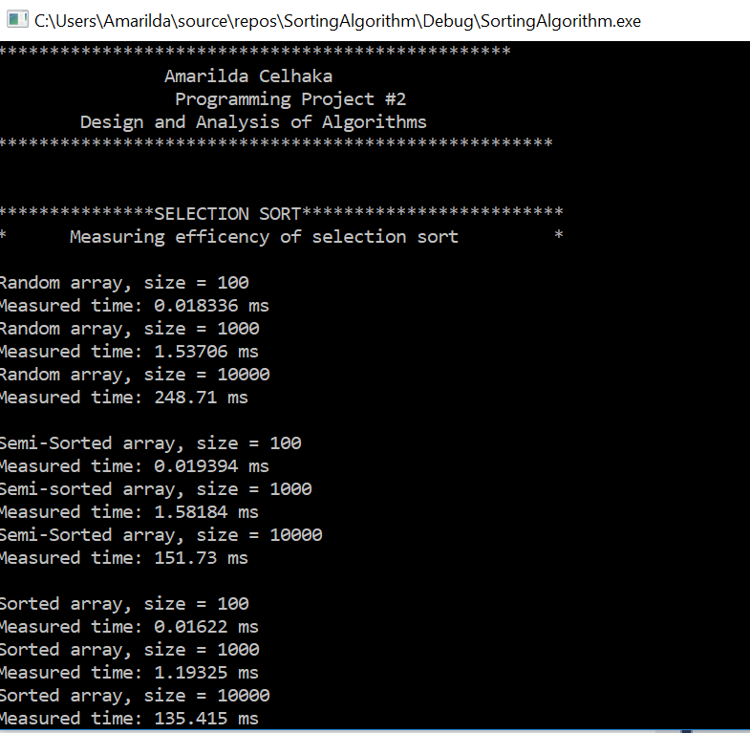

**Insertion Sort Results**

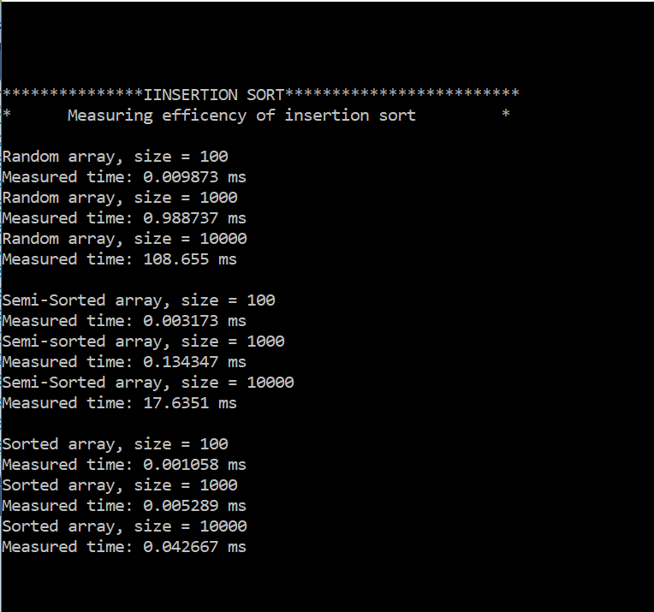

**Bubble Sort Without Counting Swaps Results**

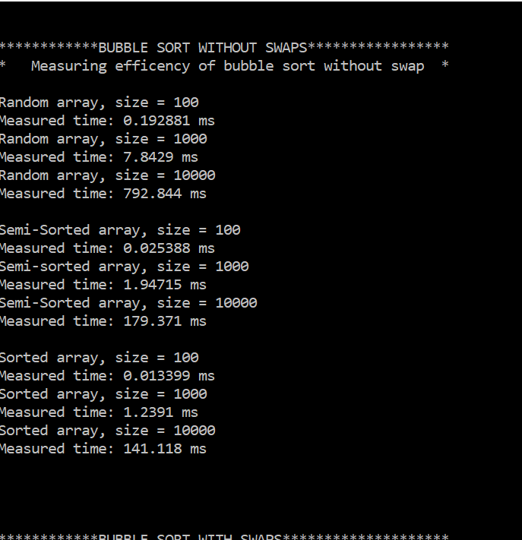

**Bubble Sort With Swaps Counting Results**

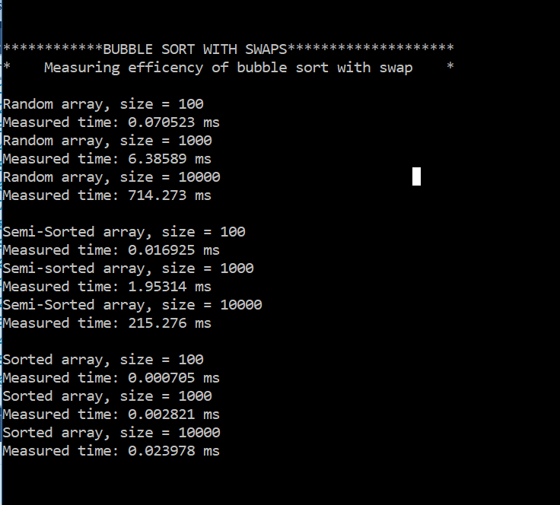

**Quick Sort Results**

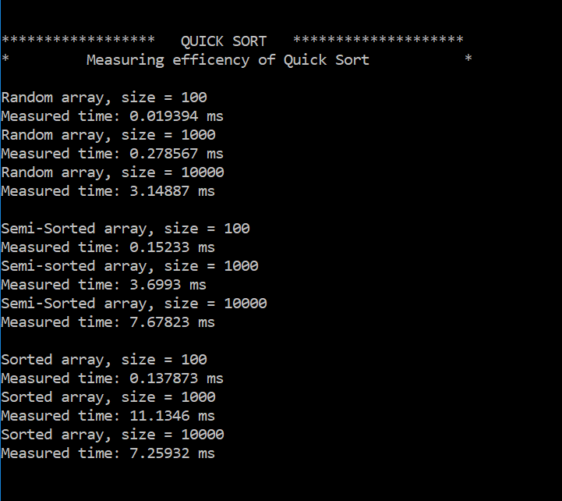

**Merge Sort Results**

